**Title : Project-DevOps-Jenkins-Installation**

1. Installing Jenkins in AWS Linux machine

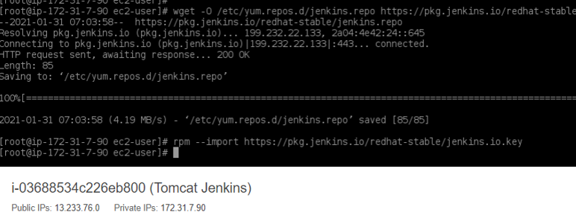

1. Jenkins service status check

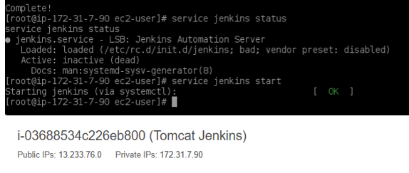

1. Extracting the password from the path

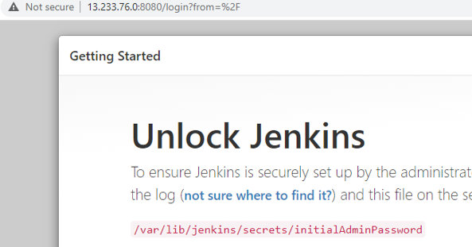

1. Start using the Jenkins

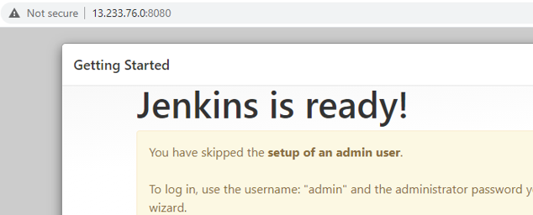

1. Creating the new job and executing the shell command

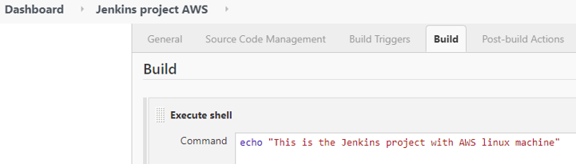

1. Build the project

